**Role B : Interrail**

To begin with, I am going to present Interrail to you. It is a train ticket which allows you to travel all over Europe.  We have planned our trip in function of the Inter-Rail Pass that we bought. There are several durations.

We will take the option 10 days at 301€. This option allows us to take the train 10 days during the month. You will see later that we will visit only 5 countries but thanks to this option we will be able to visit many cities and, as SNCF is not sure, we must predict train problems such as delay for example.

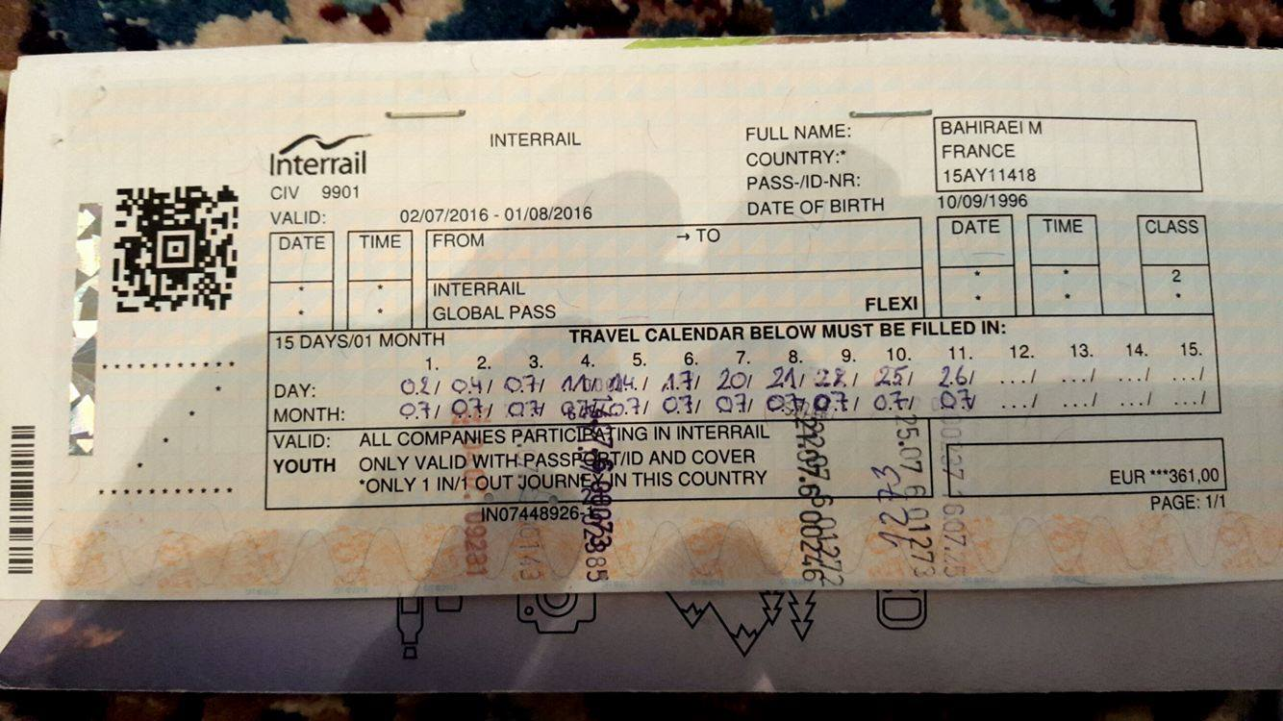

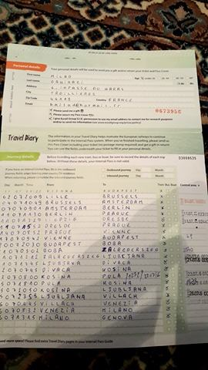

**Where do you want to go?**

The goal of this type of travel is to visit as many countries as possible. So, guys, we will travel across Europe. Like you, we will start from Rennes. Then, we will go in Amsterdam, in Berlin, in Vienna, in Turin and to finish, we will go in Madrid. In addition to these cities, we will visit others such as Milan and Rotterdam.

Thanks to these different destinations we will discover different cultures. I would have like visiting more countries like Croatia or Poland but in 3 weeks we don’t have enough time. We will see that it is the best way to travel so after doing this, we can start again next year with different destinations.

**How long do you plan to stay?**

We will begin our holiday on Saturday 10 June and we will be back in Rennes on Saturday 01 July. So, our travel will last 3 weeks as agreed. In order to enjoy as much as possible each country, we will stay 4 days in the one we will traverse. These 4 days allow us to move in different cities in the countries. So, in my opinion, 4 days is the best alternative to spend good holidays but also enjoy our trip.

**Which activities have you planned?**

Contrary to you, each country has its own activities. That is why I planned several ones.

First of all, in **Amsterdam**, as good tourists, we will visit the red-light district and the coffee shop. In Amsterdam, there is a particularity with the night club because they close at 8 o’clock am. So, we will go in party. Also, we will go in Rotterdam to visit the port. For 53€, we will sleep at the Stayokay Amsterdam Stadsdoelen.

Then in **Berlin**, we will visit the Alexander Platz, Checkpoint Charlie and the Brandenburg tor. Both we are football fan so, we will go in OlympiaStadium. For 32€, we will sleep at the Youth hostel international.

Then in **Vienna**, there are some monuments to visit such as Belvedere, Café Central and the castle of Schonbrunn. After having visit all of this, we will spend a day in lake of Neusiedll. The lake is at 1h30 from Vienna. For 27€, we will sleep at Myrthengasse.

Then in **Turin**, we will visit Palazzo Madama, la Mole Antonelliana and Parco del valentine. We will also discover the stadium.

We will spend a day in Milan, in order to visit the city and the stadium. For 27€, we will sleep at Torino.

To go in Madrid, we will do a stop in **Nice** for a day. We will enjoy the sea and the Promenade des Anglais. For 9€, we will sleep at the Hi Nice Camélia.

Next day we will go in **Madrid** where there are the Grand Via, the royal palace, the plaza Mayor and to finish, Santiago Bernabeu. For 24€, we will sleep at Concordia.

In each country, we will sleep in youth hostel. On the one hand, it is less expensive and, on the other hand, this type of accommodation allows us to share good moments with other people.

**How much would it cost?**

The price of this travel is 970€ per person. Indeed, there is a lot of thing to take into account. 301€ for the ticket, then the price of the different accommodations and I have decided that we will spend 100€ in each country, and the price of shopping.

**Why do you recommend this type of holiday?**

Thanks to this type of holiday we can know and discover a big part of Europe. With the interrail pass we can explore 40 000 destination.

Travel with the train is a good thing because there is not the tiredness of the car. With the train, we are free.

As we can go everywhere, each travel is different and adapted for each people.

Rennes à Amsterdam 6h30

Amsterdam à Berlin 6h30

Berlin à Vienne 11h30

Vienne à Turin 10h40

Turin à Nice 8h30

Nice à Madrid 12h20

Madrid à Paris 9h30

Paris à Rennes 2h

Départ samedi 10 juin et retour samedi 01 Juillet :

Samedi 10/08 départ gare de Rennes à 7h

10/08 Arrivé à Amsterdam à 13h30

14/08 Départ d’Amsterdam à 7h

14/08 Arrivé à Berlin à 13h30

18/08 Départ de Berlin à 7h

18/08 Arrivé à Vienne à 18h30

22/08 Départ de Vienne à 7h

22/08 Arrivé à Turin à 17h30

26/08 Départ de Turin à 7h

26/08 Arrivé à Nice à 15h30

27/08 Départ de Nice à 7h

27/08 Arrivé à Madrid à 19h30

01/07 Départ de Madrid à 7h

01/07 Arrivé à Paris à 16h30

01/07 Départ de Paris à 18h

01/07 Arrivé à Rennes à 20h30